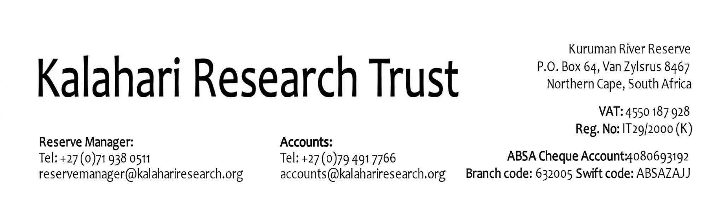

INDEPENDENT RESEARCHERS

APPLICATION TO BRING AN ASSISTANT / ASSOCIATE / STUDENT / VOLUNTEER / TO WORK AT THE KALAHARI RESEARCH CENTRE (KRC)

This form is to be completed by all Independent Researchers (IR) bringing assistants (within the following categories: paid field assistant, associate/partner, student, volunteer) to work at the KRC and must be completed for each person and filed with the Reserve and Project Manager before they start work.

- Assistant / Volunteer / Student / Associate details:
Name (last & first name, function):

Category of assistant (relationship to IR):

Immigration status (SA resident, visa): Valid until:

Address:

Affiliation (Institute, University etc.):

Email address:

Mobile phone:

- Proposed activities / work?

- Date of arrival and departure at the KRC?

- Will they be at KRC when you are not there? ☐ Yes ☐No
Reason: Who supervises?

- Will they be expected to drive on the Reserve: ☐ Yes ☐No
if yes, on the public road: ☐ Yes ☐No
on town trips: ☐ Yes ☐No
Do they have an International Driver’s license? ☐ Yes ☐No
Are they insured to do drive? ☐ Yes ☐No
By whom are they insured?.IR?

- What vehicles will they use, IR or GS project?

- Has the KRC Reserve Manager (Walter Jubber) confirmed that there is accommodation available for them? ☐ Yes ☐No

- Who will pay for their accommodation and Communal charge during their visit?

- How will they be paid?

- What arrangements are in place to provide them with funds to cover their research expenses?

- Do they have any serious medical conditions? ☐ Yes ☐No

- Do they have health insurance in place? ☐ Yes ☐No
The Emergency Contact Information Form needs to be completed for them and given to the KRC manager.

- Are they covered by Third-Party insurance? ☐ Yes ☐No
Are they insured against risks incurred while working, ☐ Yes ☐No
and, if so, by whom?

- The Emergency Contact Information Form has been filled in for them?
☐ Yes ☐No

- Have risk assessments been completed for them and filed with the KRC Reserve Manager (Walter Jubber)?

Field Work Risk Assessment Form: ☐ Yes ☐No
Leisure Risk Assessment Form: ☐ Yes ☐No

- Is their research covered by your ethical permits as well as by your conservation permits?
Ethical permits: ☐ Yes ☐No
Conservation permits: ☐ Yes ☐No
- Will they be working within the project guidelines listed in the Notes for Independent Researchers at the KRC? ☐ Yes ☐No
If not, please explain how and why?

Name (Independent Researcher):
Affiliation (Institute, University etc.):
Email address:

Signature

……………………………………………………..
Date: Location:

Please send completed questionnaire to all persons listed below:
- Marta Manser (marta.manser@ieu.uzh.ch)
- Tim Clutton-Brock (thcb@cam.ac.uk)
- Walter Jubber (reservemanager@kalahariresearch.org)
- Megan Wyman, KRC research coordinator (megan.wyman@ieu.uzh.ch)

